An ecosystem for evaluating Forensic Delay Analysis

KLINTERAI

Use Case: A Tensor Database for Construction Sector

**Use Case Summary Table**

|  |  |
| --- | --- |
| **Domain** | **Productivity Monitoring** |
| Problem to be addressed | Developing AI/ML driven solutions to identify Incidents, Risks and Issues occurring at Construction Site. |
| Key aspects of the solution | A Tensor Database that can conduct Video Analytics for a Delay Analysis in Construction Site using CCTV camera installed at Site and contribute to Image Classification for Edge Computing. |
| Technology keywords | [TensorDatabase] Anomaly Detection  [TensorDatabase] Visual Sentiment Analysis – Image Classification  [MobileApp] Risk Identification – Manual Process  [IoTEdge] Forensic Delay Analysis  [GenAI] Image Captioning of Construction Site Images, Existing Model  [GenAI] Prompts for Intent Classification of Site Activity |
| Data availability | Public data |
| Metadata (type of data) | Video from existing cctv camera |
| Model Training and fine tuning |  |
| Testbeds or pilot deployments |  |

**Use Case Description**

**Description**

Forensic Delay Analysis is a subject-area in construction sector which deals with payments to delays in construction projects. Measurement of delays are complicated in the field because of the nature of projects. Some projects have detailed plans laid out; some projects may not have detailed plans. Some are large and some are small. Some are measured while the project is ongoing whereas some are measured after the impact of the project is realized.

KlinterAI received a dataset of 14k+ images out of which few images are sent through clustering pipeline to cluster the images by separating people, certificates from construction site images. The Clustering Algorithm, BayesianGaussianMixture, of ScikitLearn correctly clusters the images. The construction site CCTV cameras pick these images and perform a visual sentiment analysis on video outputting anomalies in the video. For KlinterAI, the EquipAny mobile-app takes images as photographs and also performs risk identification. For those normal images without any risks or issues and for those EquipAny images capturing actual risks, our analysis context for a Forensic Delay Analysis occurs. Our approach reduces the lead time in identifying the analysis contexts for a Forensic Delay Analysis. In Video Analysis of CCTV Videos towards Visual Sentiment Analysis (VSA), what remains is the rolling over metric of video images. Effectively, the video output will be nullified to two regions: (1) Regions with activity, task orientation and marked as Anomaly, (2) Regions without activity and without people in PPE and marked as Normal. It becomes easier identifying the regions of interests (ROIs) through a rollover metric of the output from Visual Sentiment Analysis.

Graph obtained when VSA Model creates Frames of Areas as Outputs

**Scene Map**

Phase 1: CCTV Video is being watched through the Dashboard

Phase 2: A Construction Delay occurs at Construction Site

Phase 3: Site Engineer uses the Mobile App, EquipAny, in Site to take Screenshots of Site, Equipment, Machinery and People for Risk Identification

Phase 4: The Data Scientist looks for Delay events in the Dashboard to generate a Report on Delay Analysis

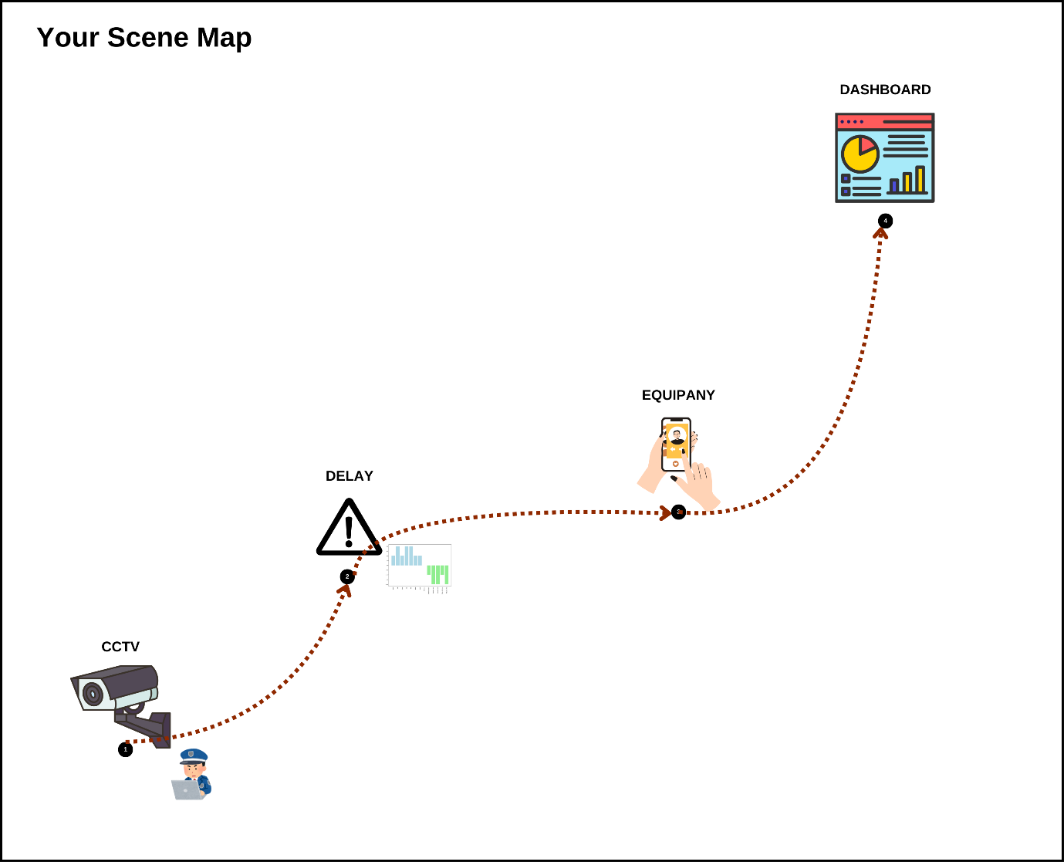

The Scene Map for a Forensic Delay Analysis

**Use case requirements**

* Delay notification is sent to the Dashboard

SRC: CCTV Video Images run through Visual Sentiment Analysis

C: IP Cameras, Relevant IoT Data through Messaging Queue installed in Cabin

M: Visual Sentiment Analysis Model installed in Cameras or the Messaging Queue

D: Messaging Queue installed in Cabin connected to Cloud

SINK: The Dashboard which connects to IP Camera(s)

* Site Engineer addresses the Risk via Delay Notification Received at Mobile Device

SRC: CCTV Video Images run through Visual Sentiment Analysis

M: Visual Sentiment Analysis Model installed in Cameras or the Messaging Queue

P: A Proper Rollover Metric Policy attached to the Model that signifies a Risk from the Delay in the Presence of an Activity

D: Messaging Queue installed in Cabin

SINK: The EquipAny Mobile App

**Use case status:** Tensor Database for Construction Site is part of An ecosystem for evaluating Forensic Delay Analysis

**UN Goals:**

* **SDG 8:** Decent Work and Economic Growth,
* **SDG 9:** Industry, Innovation, and Infrastructure,
* **SDG 16:** Peace, Justice, and Strong Institutions

**Justify UN Goals selection:** The Video Analytics and visual sentiment analysis use case for construction site as a tensor database directly contributes to three key Sustainable Development Goals (SDGs):

* SDG 8 – Decent Work and Economic Growth: Visual Sentiment Analysis measures Activity across the Site regions. Activity orientation results in understanding decent work for all people at the site. This inculcates safety at work, in a way that, people respond to delays, risks and issues based on the activity orientation developed by the ML model. It promotes sustainable economic growth to the clients and main contractors during work. Once safety at work is tracked, it gives the opportunity for the site to set goals in consumption and production progressively. More Anomalies detected at site promotes secure working atmosphere for labourers improving labour rights and active thinking in terms of safety.
* SDG 9 – Industry, Innovation and Infrastructure: Attaching to the BIM Infrastructure is a great step towards presenting AI as the core of Construction Monitoring ecosystem. Visual Sentiment Analysis combined with Monitoring the Site involves innovative approaches to solve the problem. Forensic Delay Analysis is aware of the Construction Activities when CCTV is used to monitor the site using the ML Model deployed. Forensic Delay Analysis is an innovative approach to handle client relationships and an industry-wide practice to improve reporting and risk identification.
* SDG 16 – Peace, Justice and Strong Institutions: With the Tensor Database in place, all issues related to delays, transparency of work-related issues and risks to clients. Forensic Delay Analysis brings in an ecosystem of solutions such as CCTV, Mobile App, Delay Monitoring Dashboard and such. They are integrated technologies to bring in justice and transparency to work. With a forensic delay analysis approach, the companies bring in safety monitoring and methods to detect any progressive increase of risks at site.